LAB ASSIGNMENT-14.3
Task Description #1 – AI-generated HTML Page
Task: Ask AI to generate a simple HTML homepage for a "Student Info Portal" with a header, navigation menu, and footer.
Expected Output:
- HTML code with <header>, <nav>, <footer>.
- Clean indentation, proper tags, and comments.
PROMPT:
Generate a simple HTML homepage for a "Student Info Portal" with a header, navigation menu, and footer with comments.
CODE &OUTPUT:
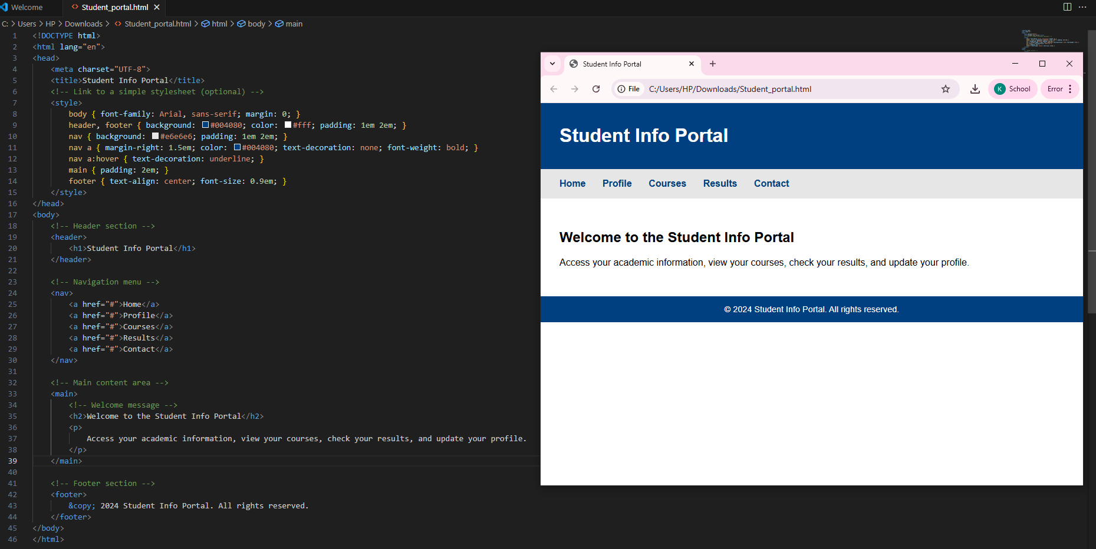
OBSERVATION:
This HTML code creates a clean and simple Student Info Portal page.
The structure is semantic, using header, nav, main, and footer elements.
The CSS is embedded in the head and provides a professional look with good color contrast.
The page is accessible and easy to read.
Task Description #2 – CSS Styling
Task:
Use AI to add CSS styling to Task #1 homepage for:
- Responsive navigation bar.
- Centered content section.
- Footer with light gray background.
Expected Output:
- HTML + CSS combined.
- AI explains how CSS classes apply.
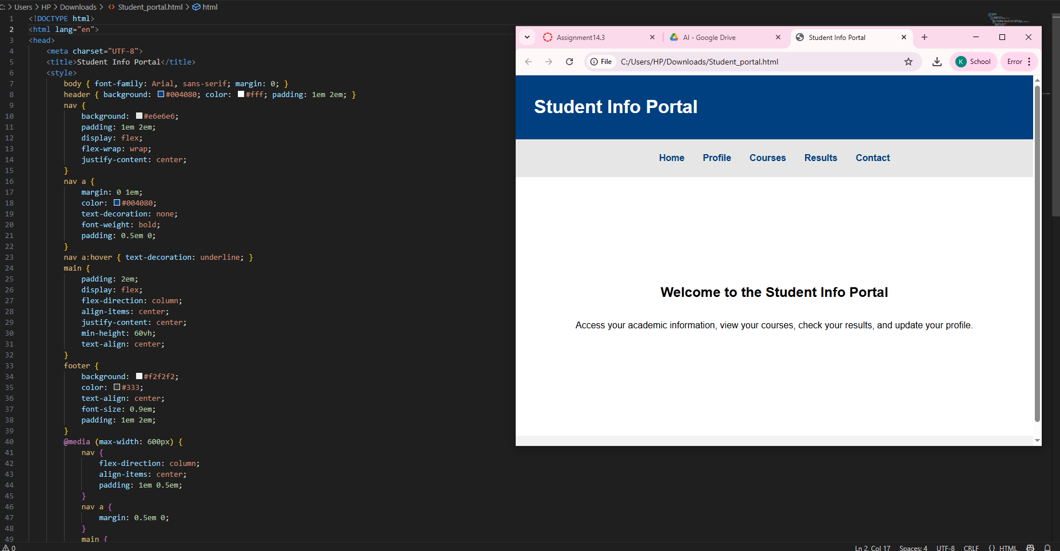
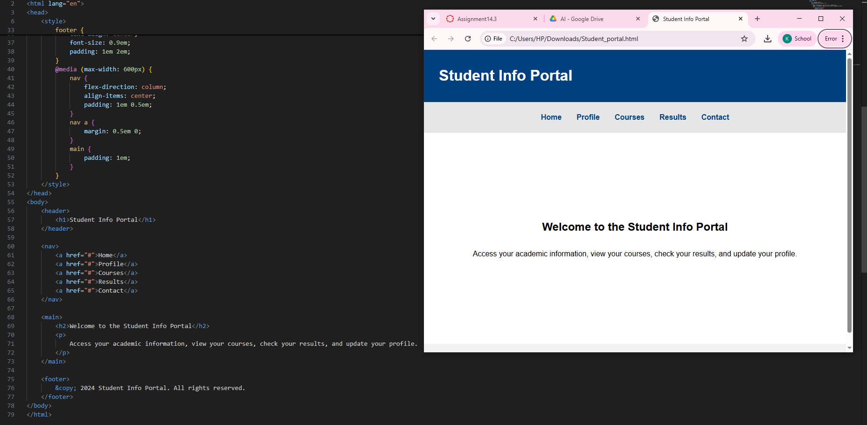
OBSERVATION:
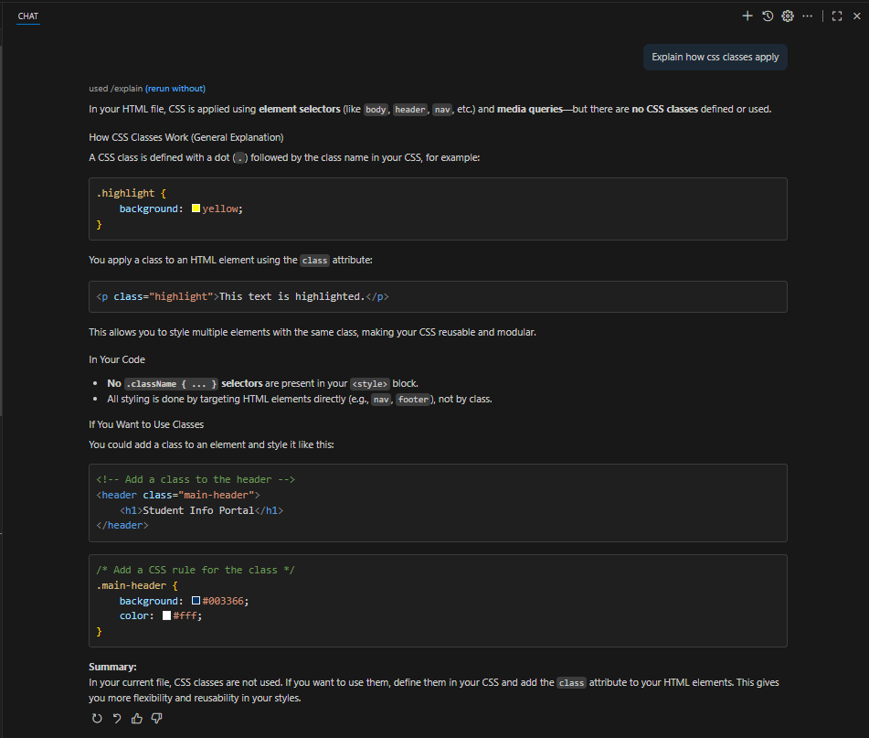
Task Description #3 – JavaScript Interactivity
Task: Prompt AI to generate a JS script that validates a simple login form (non-empty username/password).
Expected Output:
Working on submit JS validation.
Clear error messages if inputs are empty
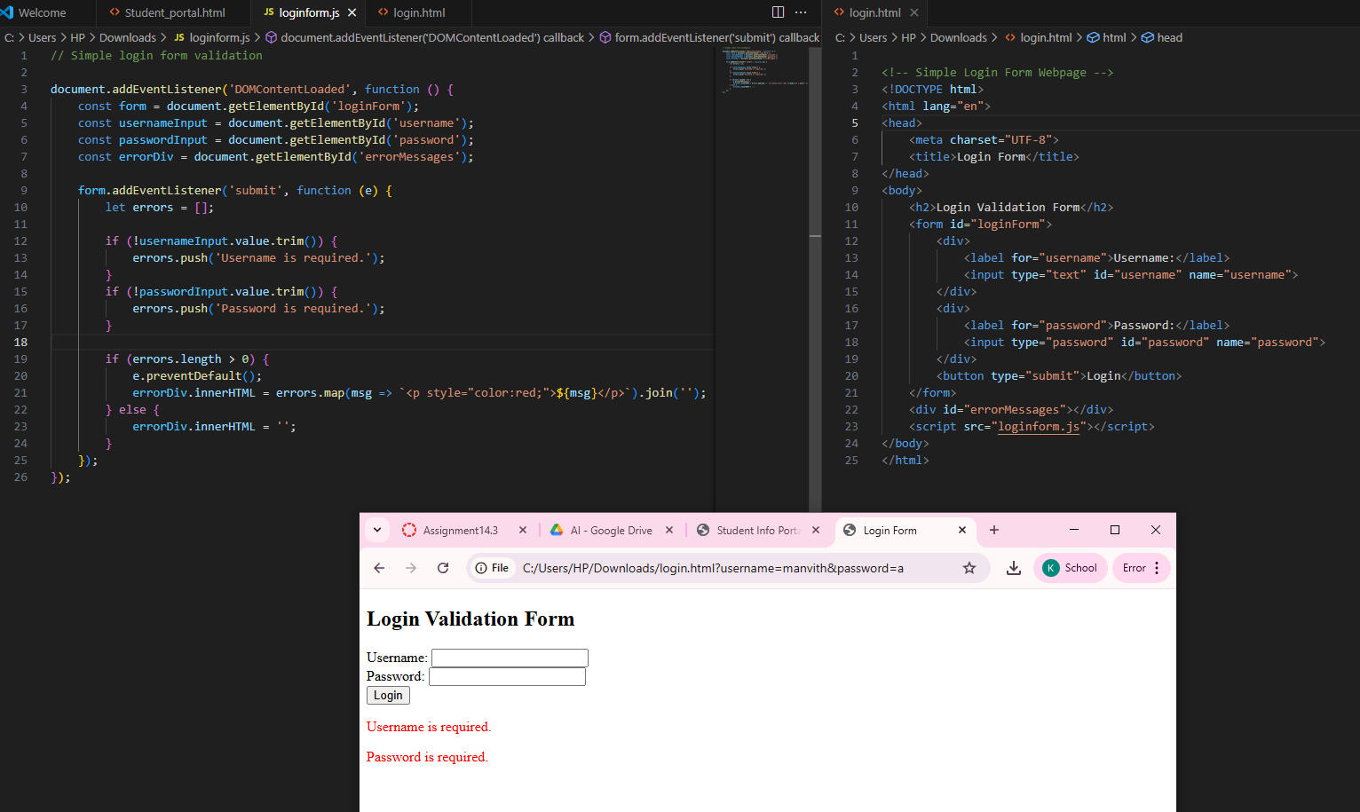
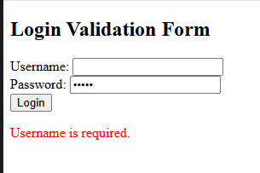
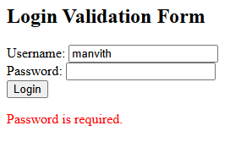
Task Description #4 – Python Backend Integration
Task: Ask AI to generate a Flask app that serves the HTML form (Task #3) and prints the username on successful login.

